Evidence for Implementation and Testing Unit

Ross Hill

Cohort E18

**I.T. 1 – Encapsulation in a program**

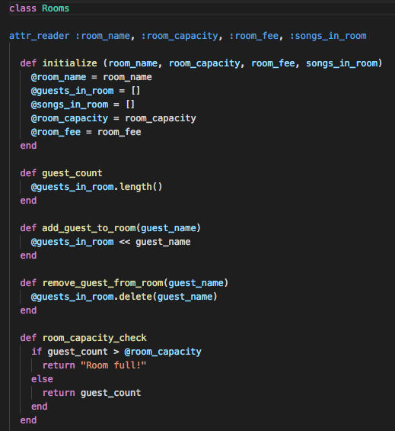

**I.T. 2 – Inheritance in a program**

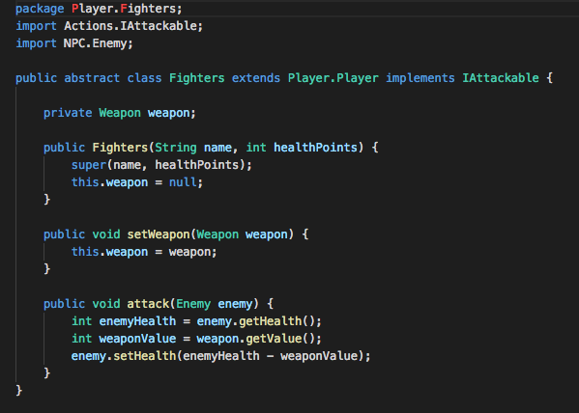

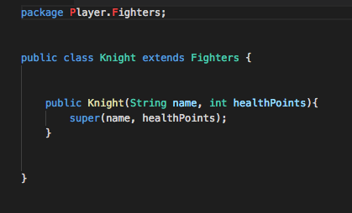

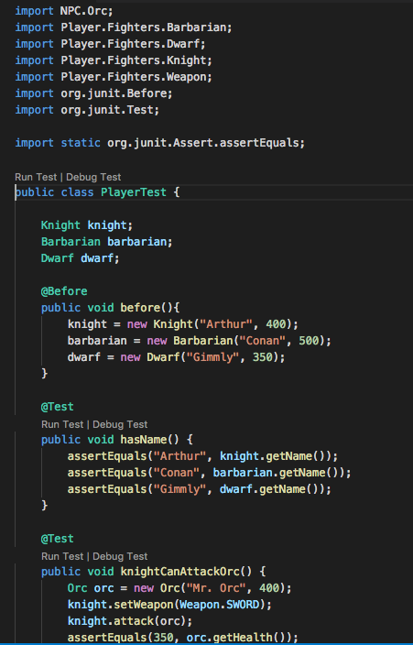

**I.T. 3 – Searching in a program**

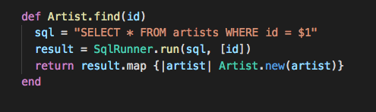

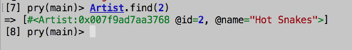

**I.T. 4 – Sorting data in a program**

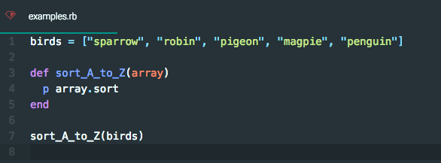

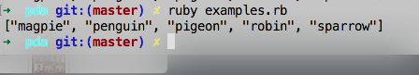

**I.T. 5 – Use of an array**

Macintosh HD:Users:rosshill:CodeClan:PDA:Screenshots:2.1.1.png

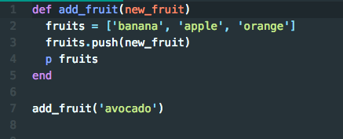

Macintosh HD:Users:rosshill:CodeClan:PDA:Screenshots:2.1.3.png

**I.T. 6 – Use of a hash**

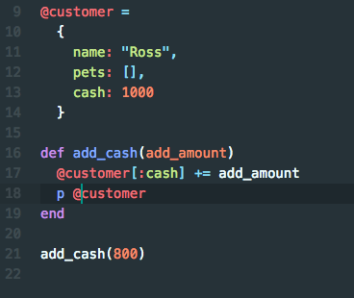

Macintosh HD:Users:rosshill:CodeClan:PDA:Screenshots:2.2.3.png

**I.T. 7 – Use of Polymorphism**

